HB cleaning
Jan-2010 MA

Example of how to clean line frequency artifacts and heart beat artifact.
Warning: the procedure works only on continuous recordings and on data with no very big and frequent artifacts.

The programs uses the pdf4D class and some of my programs which are in MEGanalysis directory. The two directories should be arranged like:

MEGanalysis
|
|_@pdf4D
|
|_private

The procedure createCleanFileF should be added to the @pdf4D subdirectory.
A sample session will look like:

fileName='C:\DATA\MEG\Heart\keren03\c,rfhp1.0Hz';
p=pdf4D(fileName);
cleanCoefs = createCleanFileE(p, fileName, ...
'byLF',[],'HeartBeat',[]);

The procedure will create a new file with the name:
hb,lf_c,rfhp1.0Hz
If such a name already exists you have to confirm that you wish to over-write it.
The procedure plots the heart beats for the first 30 s. Look on it carefully to make sure that the QRS complexes stand well above the inter-beat activity, and that the little black marks on the top fit in a one to one fashion to these complexes. Figure 1 illustrates this.

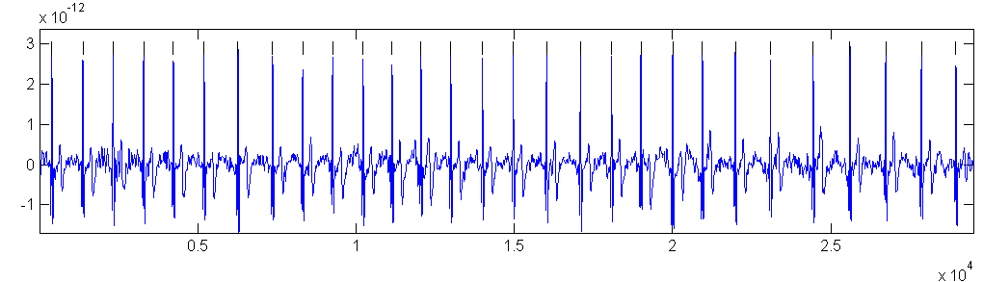
Figure 1 mean MEG signal for the first 30 s.
Abscissa – sample no. Ordinate amplitude in T. Note that the T wave varies a lot among heart beats which means it would be only partially cleaned.

Watch carefully the comments that the program produces. You may see lines like:
finding LF for: 107.0986 214.1961
Warning: MEGanalysis:overflowSome MEG values are
huge at: 214.1961 - truncated
> In pdf4D.createCleanFileE at 559
This means you should avoid analyzing MEG data near this time.

Later when heart beats are cleaned you mat see warnings like:
cleaning LF for the piece 107.0986 214.1961
Warning: Minimal QRS intervasl too small!
> In findHB01 at 92
In pdf4D.createCleanFileE at 718
Warning: Too fast Heart beat periods in 95.0317
> In findHB01 at 147
In pdf4D.createCleanFileE at 718
Warning: Too small Heart beat amplitude in 95.0317
> In findHB01 at 156
In pdf4D.createCleanFileE at 718
Again, these may be regions which you should not consider for further analysis. A summary of all these regions may be obtained at the end by:
tList = listErrorInHB(cleanCoefs)

tList =
Columns 1 through 5
194.6926 202.1303 202.1303 338.0958 338.0958

Columns 6 through 10
338.3052 428.6380 428.6675 428.6675 428.8572

Columns 11 through 14
428.8877 428.8877 449.7990 462.8744

You should look at the original MEG and the cleaned MEG around these times to decide whether you wish to eliminate them. It might be clearer if you look not on individual channels but on the mean of all channels. Assuming that the MEG data is stored in MEG and the sampling rate at samplingRate then:
t=(1:size(MEG,2)/samplingRate;
plot(t, mean(MEG,1));
will allow you to look at the suspected times.

The new file has exactly the same size as the original one, and may be processed like the original file.

Save the cleanCoefs for further analysis later:
cd('C:\DATA\MEG\Heart\keren03');
save cleanCoefs cleanCoefs

NOTE in case of very big artifacts the procedure may stop with an error message. In such a case the file hb,lf_... is not cleaned! You should erase it!

